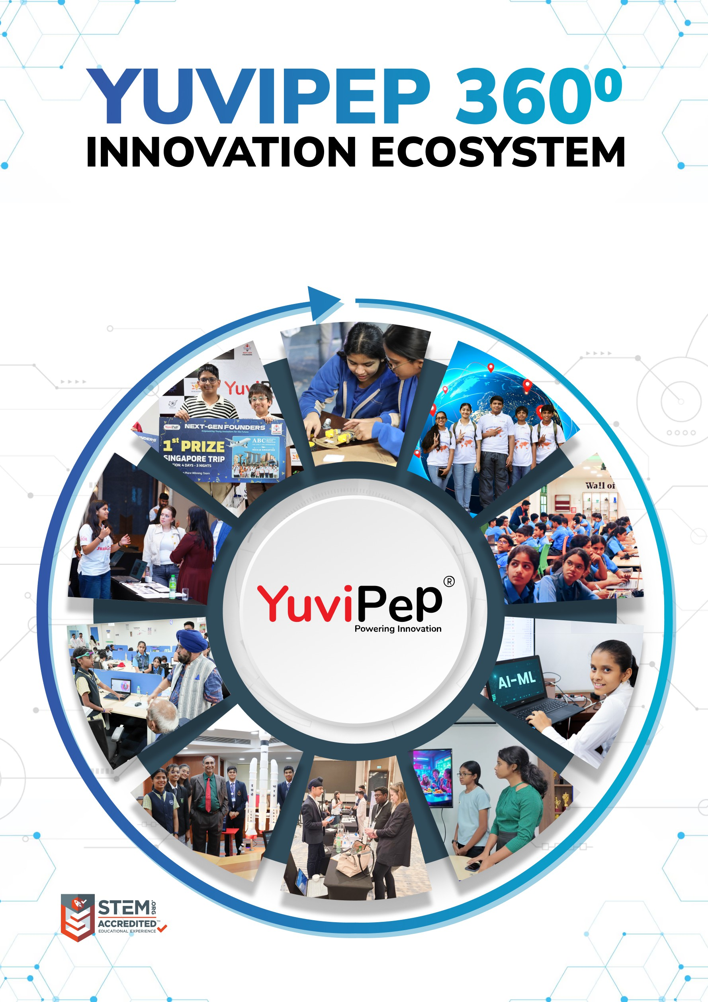
- 1 -
Copyright 2026 YuviPep© All Rights Reserved <School Name>

<School Name>

Table of Contents
ABOUT YUVIPEP 360° INNOVATION ECOSYSTEM 2
Building India’s first School-to-Startup Innovation Pipeline 2
THE YUVIPEP 360° ADVANTAGE 2
INNOVATION BASE COURSE (IBC) 3
YuviPep’s Flagship Innovation Curriculum 3
Innovation Pipeline 3
GATEWAY TO GLOBAL OPPORTUNITIES 4
MENTORSHIP, RECOGNITION AND APPRECIATION 4
YUVIPEP’S KNOWLEDGE PORTALS 5
WHAT MAKES YUVIPEP THE RIGHT CHOICE? 6
COMPETITIONS THAT YUVIPEP STUDENTS WON 7
YuviPep Students Shine at Prayag 2025 7
Record-Breaking Win at KISA Robotics Competition 2025–26 7
YuviPep Students Excel at ISF and Global Innovation Summit 8
YUVIPEP’S GROWING IMPACT ACROSS INDIA 8
INNOVATION BASE COURSE (IBC) 9
Curriculum Overview 9
Grades 1 and 2 9
Grades 3 and 4 10
Grades 5 and 6 12
Grades 7 and 8 13
Grades 9 and 10 15
INSIDE THE YUVIPEP 360° PROGRAMME 17
Programme Aligned with NCERT and NEP Guidelines 17
Enhancing English Language and Communication Skills 17
Life Skills Development through the IBC Programme 17
YUVIPEP ESSENTIAL LAB 18
Essential Lab 18
INVESTMENT AND DELIVERABLES 19
Pricing Structure 19
Payment Terms and Options 19
EXECUTION AND OPERATIONS PLAN 20

About YuviPep 360° Innovation Ecosystem

Building India’s first School-to-Startup Innovation Pipeline
The 360° Innovation Ecosystem is a full-stack platform embedded within academic environments. It creates a structured pathway in which students move from foundational innovation learning to advanced technology application, industry immersion, prototype development, incubation, and investor readiness.
YuviPep 360° Innovation Ecosystem is a future-focused, integrated platform designed to transform how students learn, create and lead. It operates as a comprehensive, interconnected framework rather than a standalone programme, strengthening academic environments, enhancing student outcomes and creating a clear pathway from learning to leadership.
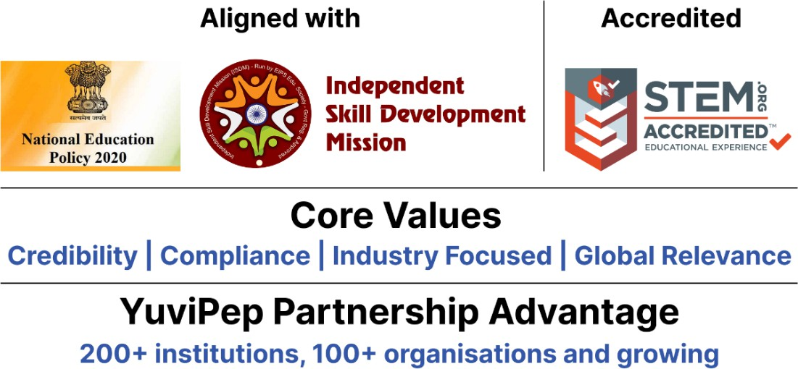

The YuviPep 360° Advantage
Built on ten strategic pillars, the YuviPep 360° Advantage creates a powerful ecosystem that connects learning with industry, innovation and global opportunity.
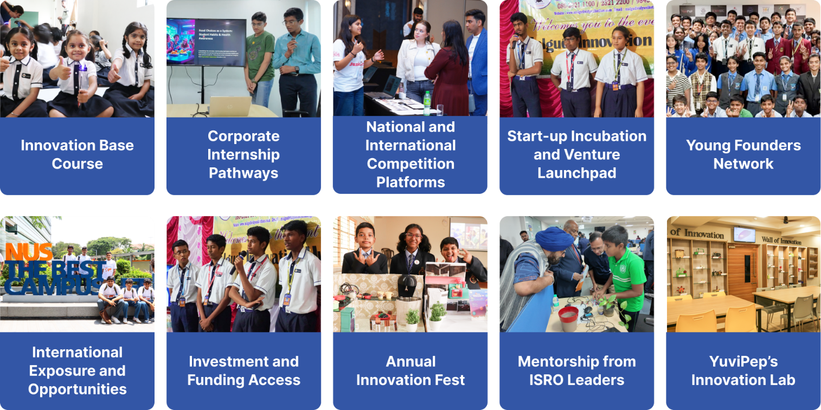

Innovation Base Course (IBC)

YuviPep’s Flagship Innovation Curriculum
The Innovation Base Course is a structured, hands-on STEAM learning platform integrated into the school curriculum. Students explore Practical Science, Design Thinking, Coding, Mechatronics, Automation, IoT, AI and Robotics through guided, application-based learning.

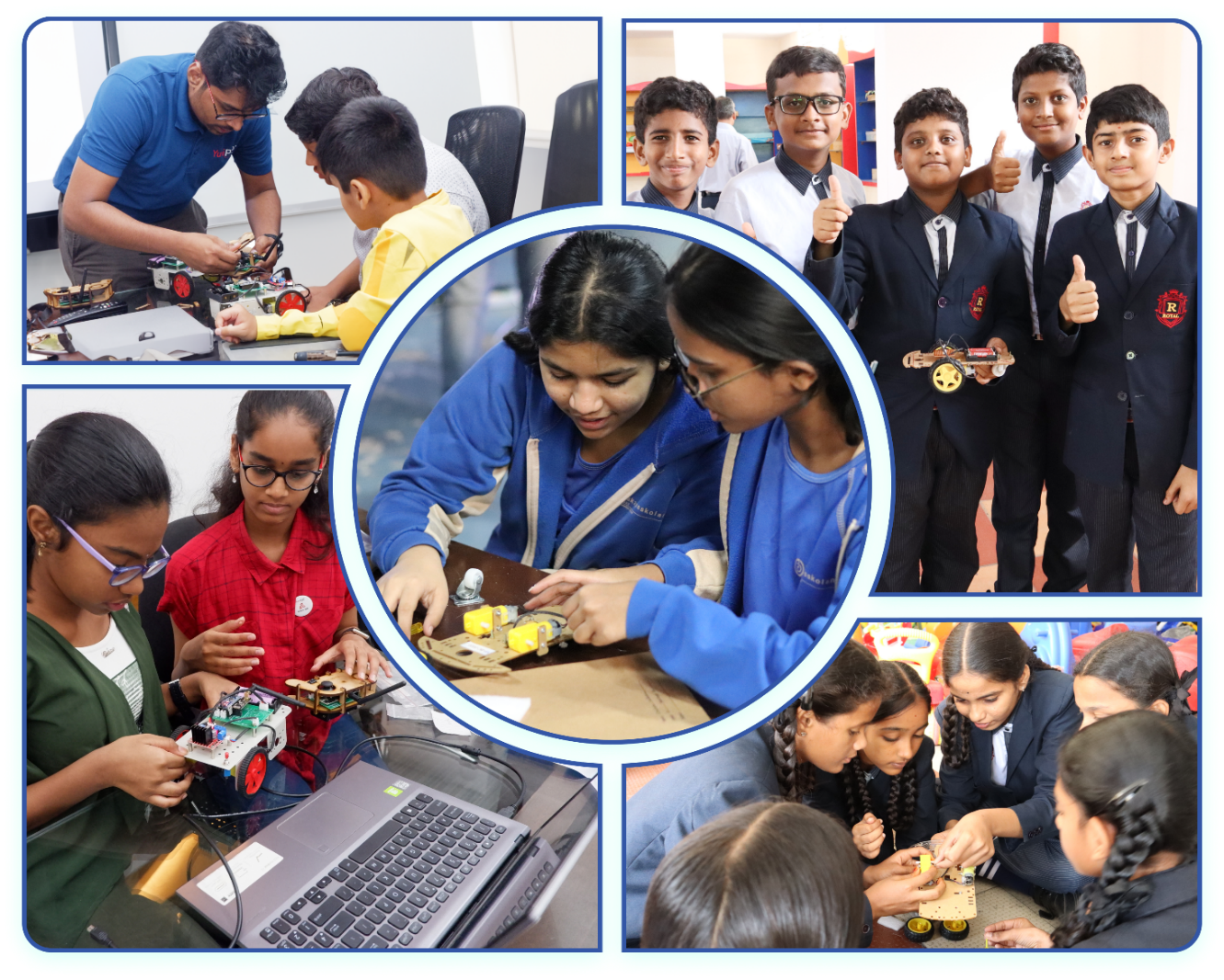

Innovation Pipeline
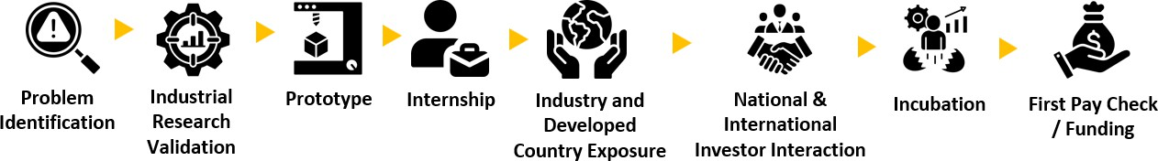

Gateway to Global Opportunities
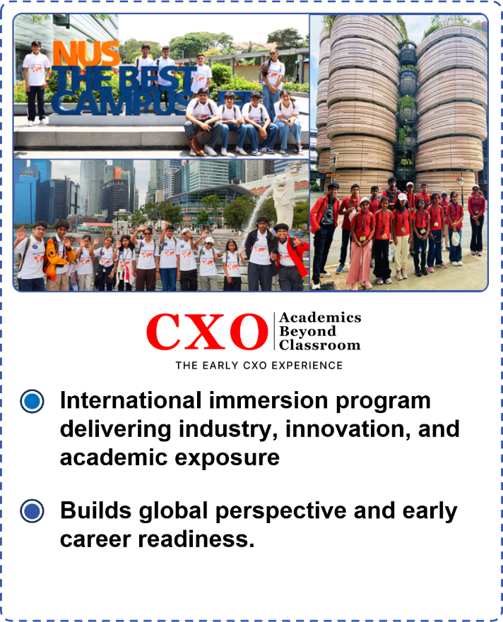
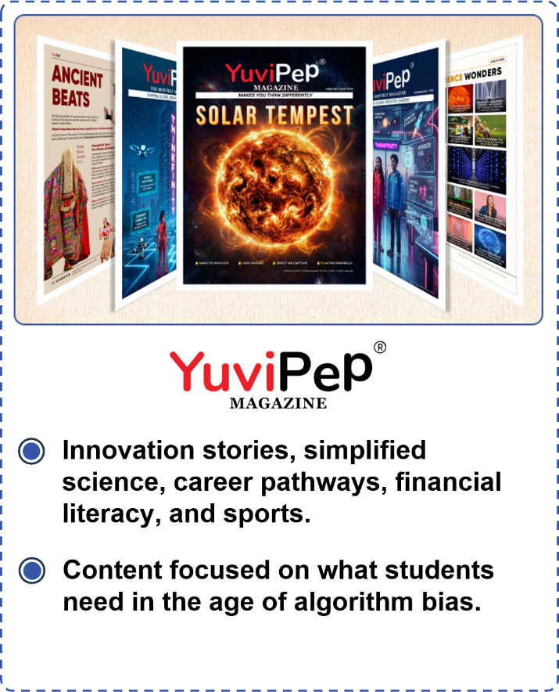

Mentorship, Recognition and Appreciation
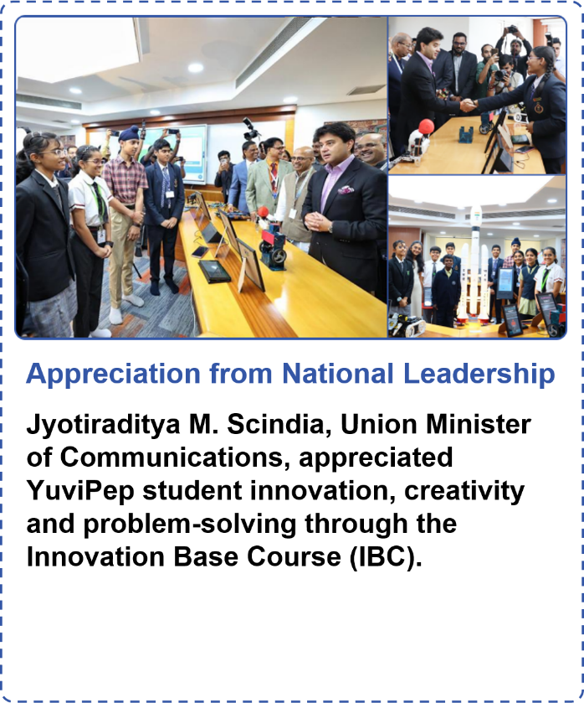
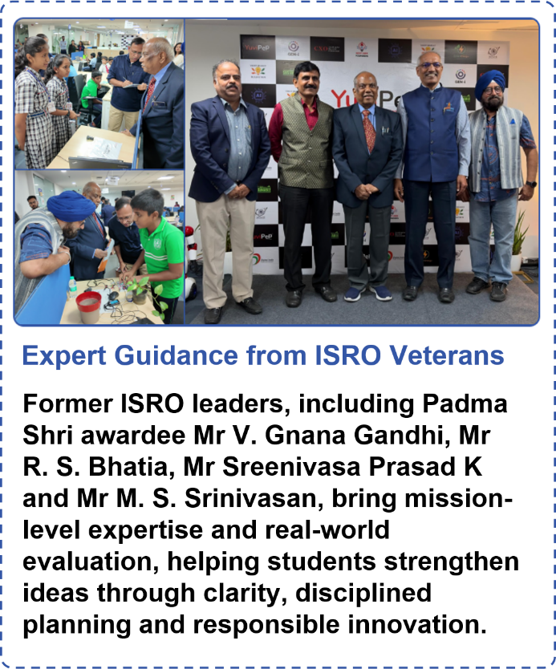

YuviPep’s Knowledge Portals
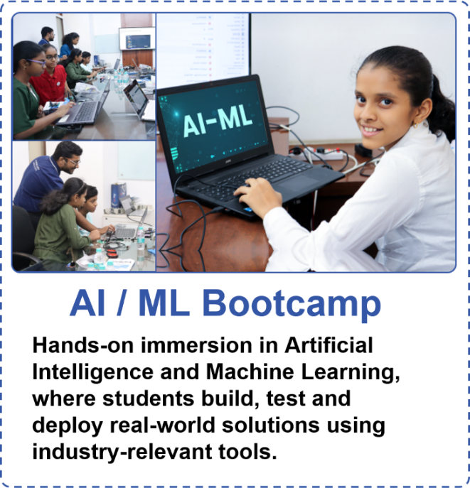
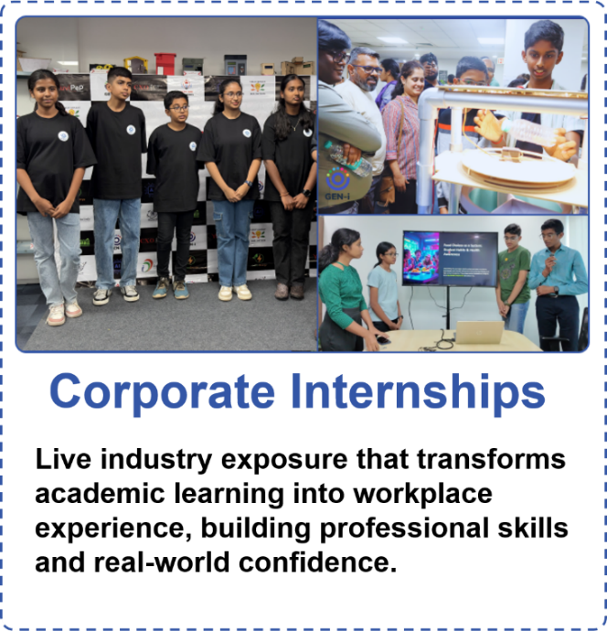
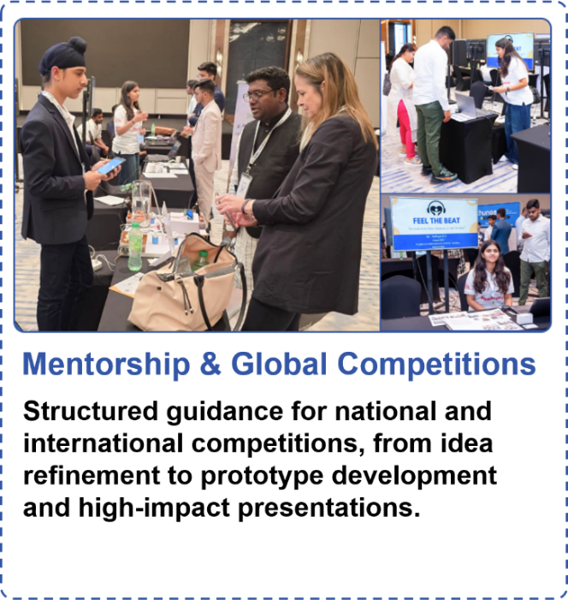
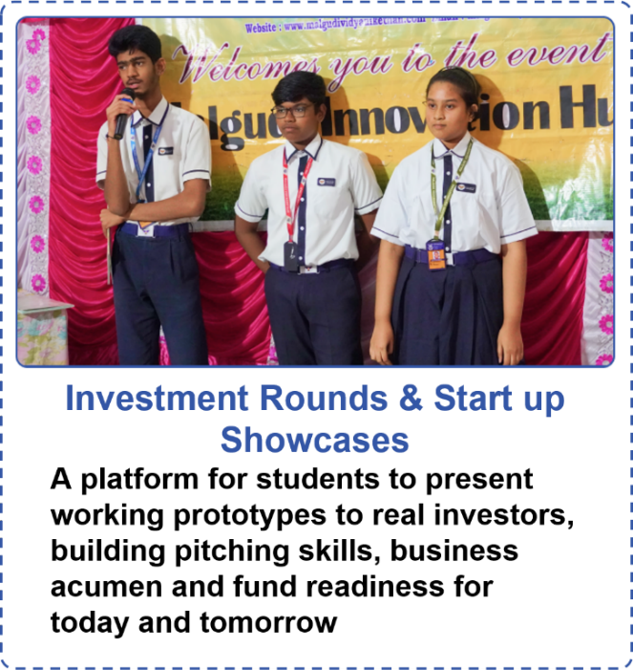

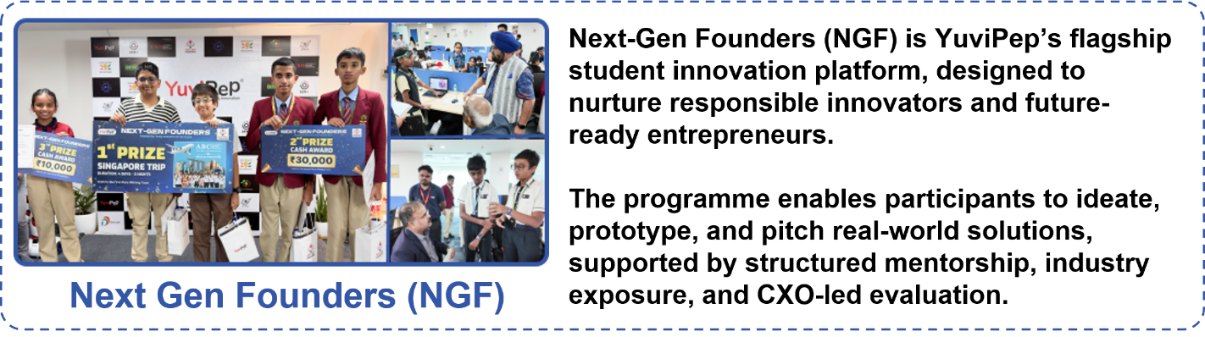

What Makes YuviPep the Right Choice?

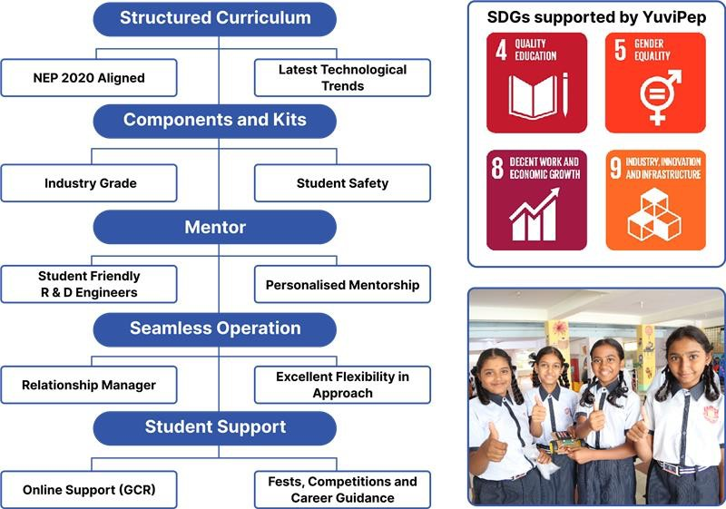
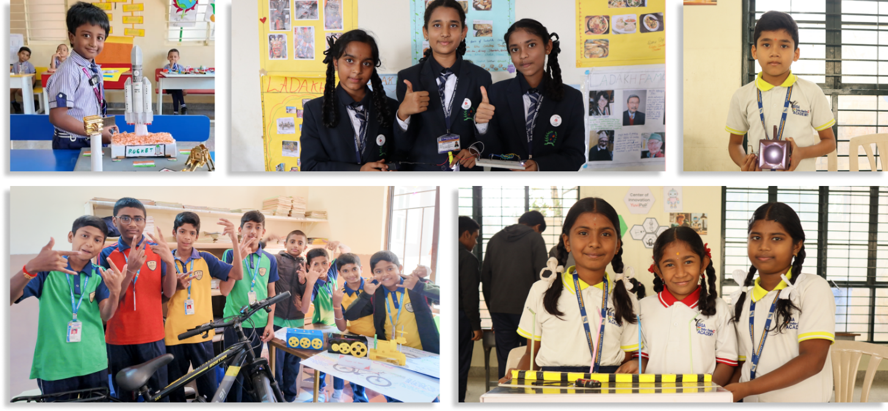

Competitions that YuviPep Students Won

YuviPep Students Shine at Prayag 2025
YuviPep students showcased outstanding innovation and problem-solving skills at Prayag 2025, organised by the Adi Shankara Institute of Science and Technology in Angamaly on 18th and 19th September 2025.
- Cryptic Codex (18th September) – First Prize:
Team Members: Jayden Liju Daurav, B. Vishnutejass, Unnikrishnan Pradeep, Sakaria Sunny
- IdeaǪuest (19th September)
  - Team 1: Josua Baju (XII), Adheen P. Wilson (XII), Chris Joseph Joby (XII) – Second Prize
  - Team 2: Michael Baju (XI), Janet Kallarackal (XI) – Third Prize
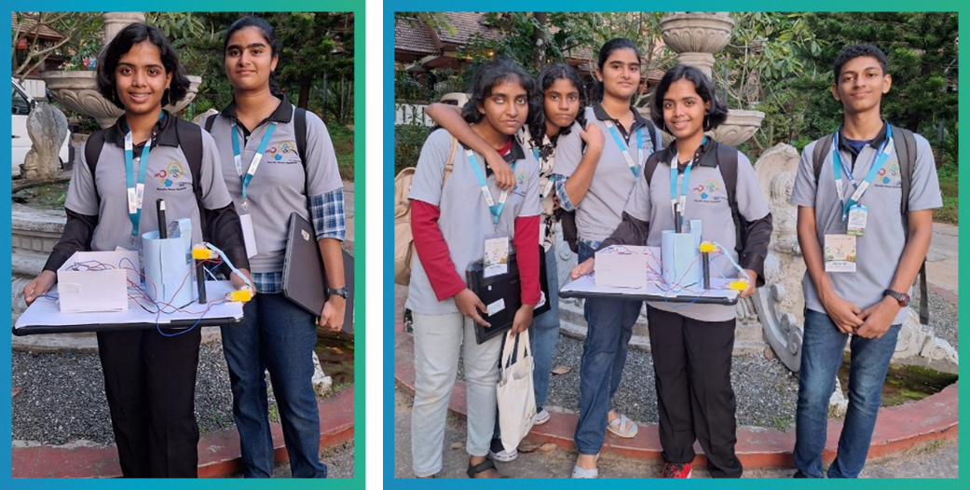

Record-Breaking Win at KISA Robotics Competition 2025–26
YuviPep students from Swargarani School and Vidya Jyoti School showcased exceptional talent at the KISA Robotics Competition – Regional Level 2025–26, competing against 73 schools and over 260 participants.

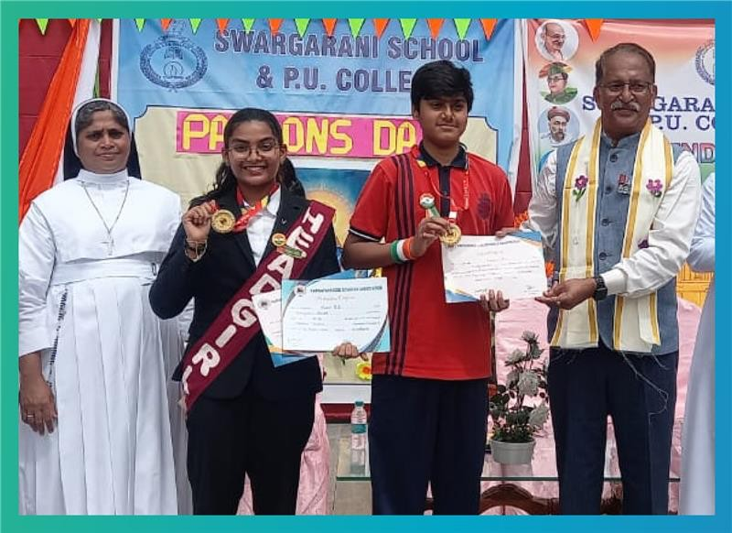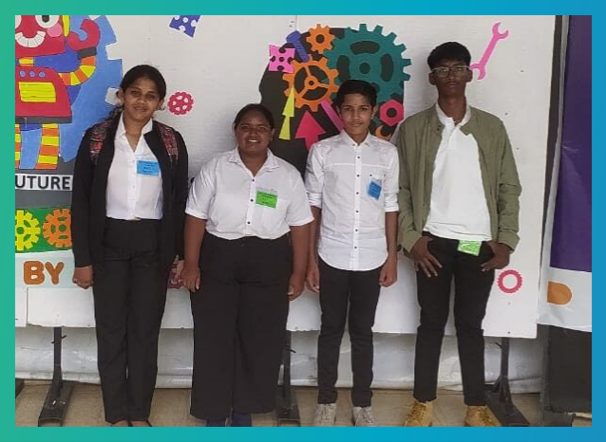

Swargarani School
Pranav B. S. and Avani M. Raghavendra won First Prize

Vidya Jyoti School
Students secured Second Prize

YuviPep Students Excel at ISF and Global Innovation Summit
As part of the 100K Initiative, which saw thousands of students from Grades 1–10 and above submit ideas through the Ideathon portal, four YuviPep students were among the finalists at the International Startup Festival (ISF) Hyderabad.
From this group, Adhya K.V (Prudence International School) and Jaswin Baweja (Sir Mutha School) were shortlisted for the Global Innovation Summit C Retreat – Dubai 2026.
At the world stage, over 70 Junicorn teams from India and the UAE pitched at the Manipal Academy of Higher Education (MAHE), presenting directly to Idea Seed Angels and international VCs.
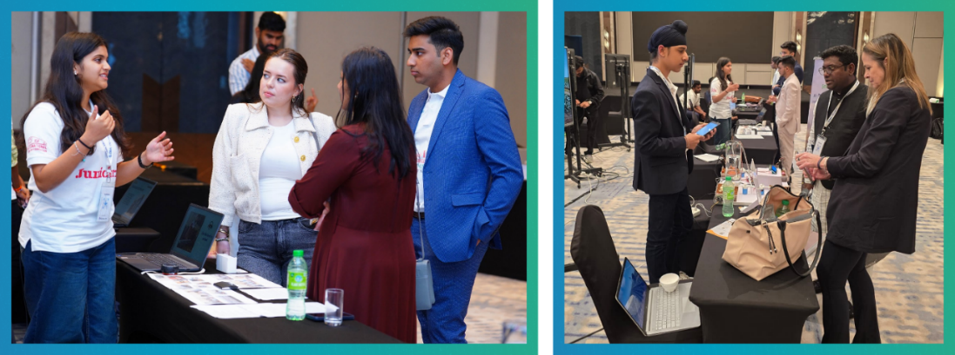

YuviPep’s Growing Impact Across India
A rapidly expanding national presence driving innovation, skill development and future-ready learning across institutions in India.
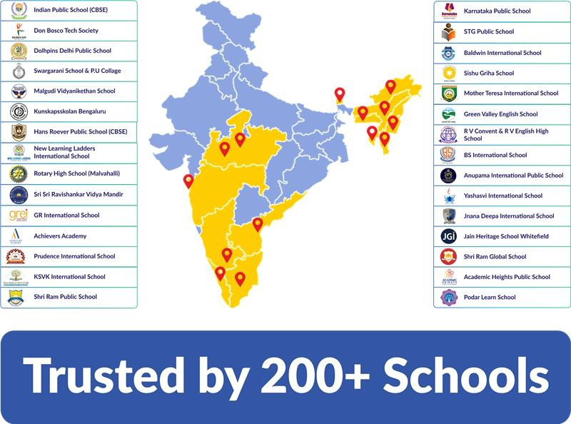

Innovation Base Course (IBC)

Curriculum Overview
A progressive hands-on STEM programme where students design, build, and present real technology systems across robotics, AI, IoT, and digital fabrication. The following is a sample representation of the IBC curriculum, providing a clear view of what students will learn and experience through the programme.

Grades 1 and 2

Topic Name | Activities Involved | Learning Outcomes
My Little House Light | - Connects a battery, wires, and a light.  - Builds a small house light model.  - Checks how the light glows when all parts are joined properly. | - Learns that electricity can make a light glow.  - Understands that all parts must be connected for it to work.  - Builds a simple light model with  confidence.
Conductivity Detectives | - Tests different objects in a simple circuit.  - Finds which things let electricity pass.  - Sorts objects into “works” and  “does not work” | - Learns that some materials let electricity pass.  - Notices that some materials stop electricity.  - Practices guessing, testing, and  checking.
My First Doorbell | - Builds a simple buzzer or doorbell setup.  - Uses a push button to make it work.  - Tries a rocker switch with an LED. | - Learns what a switch does.  - Understands that pressing a button can make something work.  - Sees the difference between push  and on-off switches.
Colour Magic Buttons | - Presses buttons to control an RGB light.  - Tries different button combinations.  - Watches colours mix and change. | - Learns that colours can mix and change.  - Understands that pressing buttons gives different results.  - Enjoys exploring through play and  discovery.
Mini Fan Makers | - Joins a motor and fan blades.  - Builds a simple fan model.  - Watches the fan spin when connected to power. | - Learns that a motor helps things move.  - Sees how electricity can create motion.  - Builds and observes a moving model  safely.
Brick Builders – Imagine C Create 1 | - Uses bricks to make simple shapes and models.  - Tries small building challenges.  - Builds using own ideas and imagination. | - Learns about simple shapes while building.  - Improves hand control and building skills.  - Starts thinking about how to make  things stand and fit.

Brick Builders – Imagine C Create 2 | - Builds taller, stronger, or themed models.  - Tries working in teams to build new models to create a solution to a  problem. | - Tries new ideas while building.  - Learns how to improve a model.  - Builds patience and problem-solving skills.
Gear Spin Fun | - Connects one gear to another gear.  - Turns one gear and watches the others move.  - Compares big and small gears. | - Learns that gears help move other parts.  - Sees that gears can spin in different directions.  - Notices that gear size can change  movement.
Power with Hands | - Builds a hand-powered light model.  - Turns a handle or rotating part by hand.  - Observes the light glow from movement. | - Learns that moving by hand can make power.  - Sees that turning can help a light glow.  - • Understands that movement can  create energy.
Wind Power Wonder | - Builds a simple windmill model.  - Makes the blades spin using air or by blowing.  - Observes how spinning parts work. | - Learns that wind can help things move.  - Understands that spinning parts can do useful work.  - Begins to connect wind with energy.

Grades 3 and 4

Topic Name | Activities Involved | Learning Outcomes
Glow C Go! — Simple Circuits with LEDs | - Builds a working circuit using a battery, LED, and switch.  - Experiments with reversing LED connections to observe polarity effects.  - Tests circuit behaviour by breaking and reconnecting the circuit at different points.  - Explores simple real-life models such as torch lights and table  lamps. | - Understands how electric current flows in a complete circuit.  - Identifies components such as battery, LED, and switch.  - Differentiates between open and closed circuits.  - Recognises polarity in LEDs.
Bright or Dim?  — Playing with Resistors | - Inserts resistors of different values into an LED circuit.  - Observes and compares changes in LED brightness.  - Sets up and compares high-resistance and low-resistance circuits.  - Builds a castle decoration model using LEDs with varying brightness  levels. | - Explains the role of a resistor in limiting current.  - Predicts how changing resistance affects LED brightness.  - Understands the relationship between resistance and circuit output.  - Applies resistor concepts in a creative real-world model.
Turn the Knob — Controlling Light Smoothly | - Introduces the potentiometer and its function in a circuit. | - Understands that a potentiometer is a variable resistor.

 | - Connects a potentiometer to an LED circuit.  - Adjusts the knob to vary LED brightness.  - Builds a headlight model with  adjustable brightness. | - Explains how resistance can be changed continuously in a circuit.  - Describes the effect of changing resistance on LED brightness.  - Identifies the difference between  fixed and variable resistance.
Conduct or Block? — Exploring Materials | - Builds and uses a simple LED continuity tester.  - Tests different materials such as a metal coin, pencil graphite, rubber band, plastic ruler, aluminium foil, and wooden stick.  - Observes whether the LED glows for each material.  - Classifies materials based on  conductivity. | - Classifies materials as conductors or insulators based on observations.  - Understands that conductors allow electric current to pass through, while insulators do not.  - Identifies common conductive and insulating materials.  - Explains the role of materials used in electrical connections.
Mix the Magic — Colours with RGB LEDs | - Introduces an RGB LED and its three colour components: red, green, and blue.  - Activates individual LEDs and observes colours.  - Combines different LEDs to produce new colours.  - Builds a castle model with an RGB LED as an indicator and backlight.  - Decorates the castle using different  colour LED combinations. | - Understands that RGB LEDs combine red, green, and blue light to produce different colours.  - Identifies primary colours of light: red, green, and blue.  - Describes how combining different light intensities produces new colours.  - Observes the effect of multiple LEDs working together in a circuit.
Click C Glow — Open and Closed Circuits | - Introduces push buttons and slide switches.  - Builds a simple circuit using a switch and an LED.  - Observes circuit behaviour in open and closed states.  - Connects two switches in series and tests control.  - Integrates a switch into the castle  model to control lighting. | - Understands the difference between open and closed circuits.  - Explains how a switch controls the flow of current.  - Identifies how multiple switches affect a circuit.  - Relates switching action to turning a circuit on and off.
Spin to Move! — Introduction to Motors | - Introduces a DC motor and its parts.  - Connects the motor to a battery and observes rotation.  - Reverses the connections to observe a change in direction.  - Attaches a simple blade to visualise motion.  - Fixes and integrates the motor into  the castle model. | - Understands that a motor converts electrical energy into mechanical movement.  - Observes that reversing polarity changes the direction of rotation.  - Identifies basic motor connections in a circuit.  - Recognises rotational motion produced by a motor.
Big vs Small — Gears in Action | - Introduces gears and their purpose.  - Connects gears of different sizes. | - Understands that gears transfer motion from one part to another.

 | - Rotates one gear and observes the movement of the other.  - Compares a small gear driving a large gear and vice versa.  - Observes differences in speed and  effort while turning. | - Observes how gear size affects the speed of rotation.  - Observes how gear size affects force.  - Identifies the relationship between connected gears.
Power to Motion  — Motor C Gear Systems | - Connects a motor to a primary gear.  - Attaches a secondary gear and axle to the system.  - Runs the motor and observes how motion transfers through gears.  - Tries different gear size combinations.  - Observes changes in speed and  effort. | - Understands that electrical energy powers a motor to create movement.  - Observes how motion transfers from the motor to gears and then to other parts.  - Identifies that using multiple gears changes how motion is passed along.  - Observes that gear combinations  affect speed and force.
Up We Go! — Exploring Inclined Planes | - Builds ramps with different angles.  - Rolls blocks or wheeled objects down the ramps.  - Pushes objects up ramps and compares effort.  - Tests movement on smooth and rough surfaces.  - Integrates a ramp into the castle  model. | - Understands that an inclined plane helps move objects with less effort.  - Observes that gentler slopes require less force to move objects upward.  - Identifies that surface type affects movement.  - Recognises that friction opposes motion.

Grades 5 and 6

Topic Name | Activities Involved | Learning Outcomes
Park Entrance Light Circuit | - Builds the entrance arch light circuit.  - Connects a battery, switch, resistor, and LED.  - Tests ON and OFF operation. | - Understands a complete electric circuit.  - Learns the role of a switch and a resistor.  - Gains confidence in basic wiring.
Steadiness Game – Conductors C Insulators | - Builds a wire loop game.  - Tests materials such as metal, plastic, rubber, and wood.  - Observes LED response on contact. | - Identifies conductors and insulators.  - Understands material properties.  - Practices testing and observation.
Cafeteria Buzzers C Switches | - Builds a push-button buzzer circuit.  - Tests a touch sensor alarm.  - Explores real-life alert systems. | - Learns how switches control circuits.  - Understands buzzer and alarm use.  - Connects electronics to daily life.
Water Level Indicator | - Builds a 3-level water sensor.  - Observes LEDs turning on as water rises.  - Discusses tank monitoring  systems. | - Understands simple sensing circuits.  - Learns how electricity reacts to water contact.  - Relates sensors to real applications.
Optics Corner – Light C Refraction | - Uses a torch, prism, and glass slab.  - Observes dispersion and refraction.  - Experiments with total internal reflection. | - Understands the behaviour of light.  - Learns basic optics concepts.  - Develops scientific observation skills.

Colour Booth – Resistors C RGB Control | - Tests LEDs with and without resistors.  - Controls an RGB LED using potentiometers.  - Observes colour mixing. | - Learns why resistors are important.  - Understands RGB colour mixing.  - Controls brightness and colour safely.
Automatic Street Lights (LDR) | - Builds an LDR-based light circuit.  - Tests the light ON and OFF in dark and bright conditions.  - Connects lamp posts along the  path. | - Understands light-dependent resistors.  - Learns automatic control systems.  - Sees electronics used in cities.
Solar Park – Solar Energy Basics | - Uses a solar panel with torch or sunlight.  - Measures brightness at different angles.  - Lights an LED using solar power. | - Understands solar energy basics.  - Learns the effect of angle and intensity.  - Connects renewable energy to  electronics.
Energy Storage with Capacitors | - Charges a capacitor using a solar panel.  - Observes the LED staying on after source removal.  - Uses an LED bar to show stored  charge. | - Learns basic energy storage concepts.  - Understands capacitors in simple terms.  - Connects storage to real devices.
Series vs Parallel Circuits | - Builds series and parallel LED circuits.  - Removes one LED to compare behaviour.  - Observes brightness differences. | - Understands circuit types.  - Learns fault tolerance concepts.  - Applies knowledge to street lighting.

Grades 7 and 8

Topic Name | Activities Involved | Learning Outcomes
Lighting up an LED | - Model: Lighting up an LED using a rocker switch.  - Build a simple circuit with a battery and an LED. Control the LED using a switch. | - Understand the components of a basic circuit.  - Explain open and closed circuits.  - Build a working LED circuit.  - Identify correct polarity connections.
Brightness Builders | - Build a simple circuit with contact points, a battery and an LED. Test different types of materials. | - Understand conductors and insulators.  - Identify materials based on conductivity.  - Test materials using a circuit.  - Analyse and record results.  - Relate the findings to real-life applications.
Push Button with Buzzer | - Model: Doctor's calling bell using a push button and buzzer. | - Understand the push button as an input device.

 | - Build a simple circuit with a battery, push button and buzzer. | - Understand the buzzer as an output device.  - Build a simple alert system.  - Explain circuit completion.
Breadboard Basics | - Breadboard: Introduction to the breadboard and its layout.  - Build simple circuits on a breadboard using a battery and an LED. | - Understand the breadboard layout.  - Identify the internal connections.  - Understand the power rails and terminal strips.  - Build circuits without soldering.
Breadboard with Resistor | - Breadboard: Introduction to resistors and their importance in a circuit. Build simple circuits on a breadboard using an LED, resistors of different values and a battery.  - PCB Testing: Connect LEDs with different resistor values and compare their brightness. 1 | - Understand the function of a resistor.  - Prevent LED damage using appropriate resistors.  - Learn correct resistor placement.  - Build safe circuits.  - Understand resistor table.
Potentiometer Control | - Model: Use a potentiometer to vary LED brightness by changing the resistance.  - Breadboard: Connect the potentiometer to the breadboard and LED. Test different terminal connections to observe changes in resistance. | - Understand variable resistance.  - Control LED brightness.  - Identify potentiometer terminals.  - Observe changes in output.
Multimeter | - Breadboard: Build a basic circuit and measure voltage and resistance using a multimeter.  - Test resistance changes using a potentiometer. | - Introduction to the multimeter.  - Measure electrical values such as voltage and resistance.  - Troubleshoot circuits.  - Compare circuit behaviour.
Series C Parallel Circuits | - Breadboard: Introduction to the breadboard and its layout.  - Build series and parallel circuits using multiple resistors, an LED and a battery. | - Understand the difference between series and parallel circuits.  - Compare brightness.  - Analyse voltage and current.  - Apply the concepts practically.
Solar Panel System | - Model: Connect a solar panel to an LED. Adjust the panel angle and observe changes in LED brightness.  - Breadboard: Connect a solar panel to an LED and measure the voltage | - Understand solar energy.  - Build a renewable energy circuit.  - Observe the effect of light intensity and panel angle on output.  - Measure voltage.

 | generated under different light levels.
Windmill Generator | - Model: Build a vertical-axis windmill on the rooftop of the model.  - Multimeter: Measure the voltage generated by the windmill. | - Understand the concept of a generator.  - Observe energy conversion.  - Observe LED output.  - Measure generated voltage.

Grades 9 and 10

Topic Name | Activities Involved | Learning Outcomes
Light It Up! – Building Basic Circuits | - Build a simple LED circuit using a battery, wires and an LED.  - Turn the circuit ON and OFF using a manual switch. | - Understand the basic components of an electrical circuit: battery, wires, LED and switch.  - Explain the role of a switch in controlling current flow.
Dim the Light – Controlling LED Brightness with Resistors | - Connect a resistor in series with an LED and observe the change in brightness.  - Replace the resistor with different values (e.g. 1 kΩ, 10 kΩ and 100 kΩ) and compare brightness levels.  - Read and interpret basic resistor  colour codes. | - Understand how a resistor limits current flow in a circuit.  - Explain how resistor values affect LED brightness.  - Read and interpret basic resistor colour codes.
Turn the Knob – Variable Resistors in Circuits | - Connect a potentiometer in series with an LED and adjust the knob to control brightness.  - Replace the LED with a buzzer and observe changes in sound intensity. | - Understand how a potentiometer works as a variable resistor.  - Explain continuous current control using a potentiometer.  - Distinguish between fixed and variable resistors and their applications.  - Develop an understanding of analog  control in circuits.
Find the Fault – Circuit Diagnosis with a Multimeter | - Learn the parts, settings and safe use of a multimeter.  - Measure voltage across components.  - Use continuity mode to identify broken wires or faulty connections.  - Diagnose deliberately introduced  circuit faults. | - Identify the key functions of a multimeter: voltage, current, resistance and continuity.  - Safely operate a multimeter.  - Locate faults using continuity and voltage readings.  - Develop systematic troubleshooting  skills.
Touch C Buzz – Sensor-Based Sound Circuits | - Assemble a touch sensor buzzer circuit using a touch-sensitive module.  - Test the circuit by activating the sensor. | - Understand the working principle of a touch sensor.  - Build and test a touch-activated buzzer circuit.  - Identify input and output  components in a circuit.

Smart Lighting – LDR-Based Automatic Lighting System | - Build LED circuits using an LDR in both series and parallel configurations.  - Create an automatic lighting system that responds to light intensity. | - Compare series and parallel LED circuits in terms of brightness, voltage and fault tolerance.  - Explain why parallel circuits are preferred in homes and street lighting.  - Understand how LDRs function as  light sensors in automation.
Sun Power – Solar Panels C Optimal Angle Testing | - Connect a small solar panel to an LED.  - Test different panel angles and measure voltage using a multimeter.  - Record observations and identify  the most effective angle. | - Understand how solar panels convert light into electrical energy.  - Measure how panel angle affects power output.  - Identify the optimal angle for maximum energy generation.
Meet the Brain – Introduction to Microcontrollers | - Explore the ESP32 microcontroller board and identify its components.  - Install and use the programming IDE.  - Upload a simple "Hello World" programme.  - Explore digital and analog pins. | - Identify the key components of a microcontroller.  - Understand the role of a microcontroller as the brain of smart electronic systems.  - Upload a basic programme successfully.  - Distinguish between digital and  analog signals.
Code C Glow – Blinking an LED with a Microcontroller | - Write and upload a basic LED blink programme.  - Modify the blink speed.  - Connect an external LED and create custom blink patterns. | - Write and upload a basic microcontroller programme.  - Understand the structure of a programme using setup and loop.  - Control a digital output.  - Observe how code affects hardware behaviour.
Press to React – Reading Button Input with a Microcontroller | - Connect a push button to a microcontroller.  - Write code to detect button presses.  - Control an LED using the push button.  - Explore pull-up and pull-down  resistors. | - Understand digital input and signal reading.  - Wire a push button correctly.  - Write code that responds to physical inputs.  - Understand the purpose of pull-up and pull-down resistors.

Inside the YuviPep 360° Programme

Programme Aligned with NCERT and NEP Guidelines
The programme is thoughtfully structured to complement the NCERT curriculum and the vision of the National Education Policy (NEP) by integrating conceptual learning with hands-on application. Students explore core scientific and mathematical principles through practical experiments, design-thinking activities, and real-world problem-solving. This approach strengthens classroom learning while encouraging curiosity, creativity, and interdisciplinary thinking, ensuring that students develop strong academic understanding alongside innovation-driven skills for the future.

Enhancing English Language and Communication Skills
Through regular presentations, project demonstrations and the annual Innovation Fest, students gain valuable exposure to public speaking and communication. They learn to confidently explain their ideas, present prototypes and engage in discussions with mentors, teachers and peers. This interactive environment naturally enhances their English language proficiency, articulation and storytelling abilities, enabling them to communicate complex ideas clearly while building confidence on public platforms.

Life Skills Development through the IBC Programme

Foundation Level | Introduces students to essential life skills through collaborative activities, communication challenges and structured problem-solving exercises. These experiences develop teamwork, clear expression, analytical thinking and a positive learning mindset.
Applied Level | Builds personal effectiveness and social awareness through leadership opportunities, time-management exercises and real-life conflict-resolution scenarios. Students also practise reflection to strengthen planning, empathy, self-awareness and responsible decision-making.
Advanced Level | Prepares students with behavioural and professional competencies through ethical discussions, collaborative project management, public speaking and stress management awareness. This stage develops leadership presence, resilience, digital responsibility and effective teamwork.

YuviPep Essential Lab
YuviPep will set up an Essential Lab to provide students with hands-on exposure to our eight core pillars: Practical Science, Design Thinking, Coding, Mechatronics, Automation, Artificial Intelligence, Internet of Things, and Robotics. Transforming classrooms into hubs of experimentation, the lab will ignite creativity, problem-solving and future-ready skills.
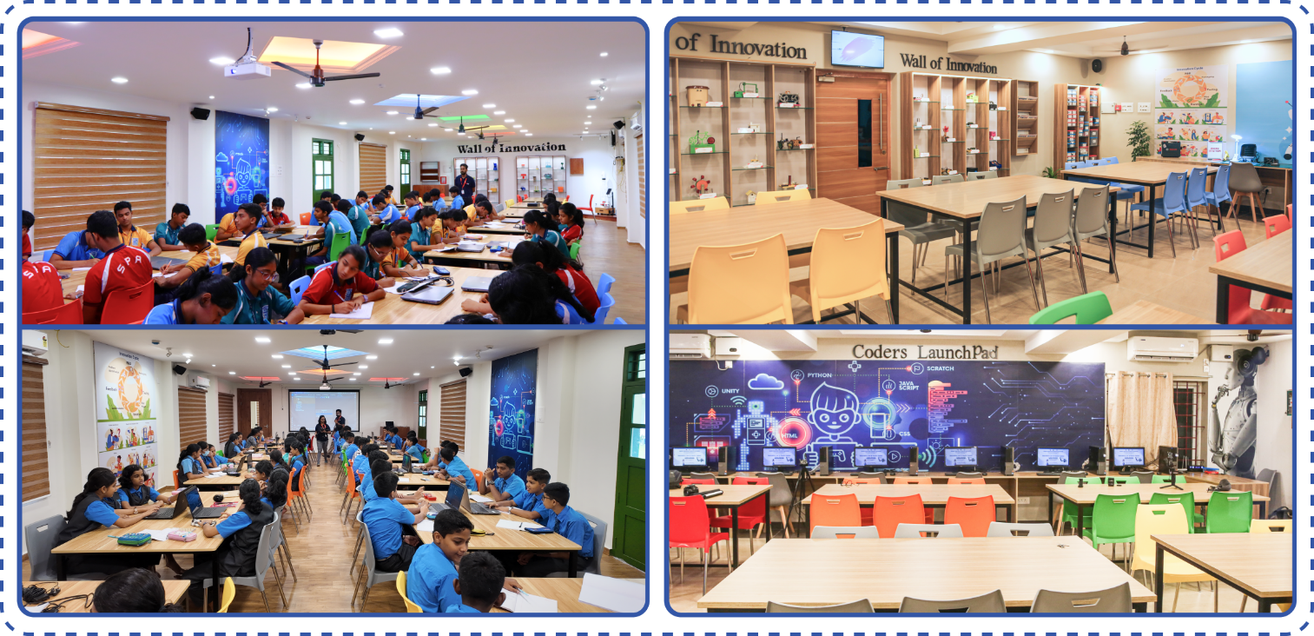
Note: The photos shown below are for reference only. The actual design, look and feel of the lab will depend on the space and interiors provided by the school.

Essential Lab

Deliverables | Essential Labs
Hands-on robotics prototypes | Included
Hands-on practical science prototypes | Included
Hands-on design thinking kits | Included
Raw prototyping kits | Included
Animatronics essentials | Included
Wall posters | Included
Pegboard with mechanical tools | Included
Soldering station | Included
Basic requirements for STEM integration | Included
Building blocks | Included
Aeromodelling and technology | Included
Hands-on agriculture and sustainability prototypes | Included

Investment and Deliverables
YuviPep’s programme deliverables are uniquely designed to ignite curiosity, nurture innovation, and empower students with future-ready skills. Every element is carefully customised to meet evolving educational needs, transforming learners into creators and problem-solvers. Below are the programme and investment details:

Deliverables | <ask:Nexus>
Essential Lab | Yes
RGD engineer | Yes
GEN-i internship | Yes
Study materials and workbooks | <ask:1 Set>
Kits and components for experiments | Yes
Innovation Fest | Eligible
Timely assessments with revisions | Yes
Project assistance | Yes
IBC certificates | Yes
Support for parent orientation | Yes
Exclusive Account Manager | Yes

Pricing Structure

Details | Annual Price Per Student | Programme Duration
Innovation Nexus | <ask_calculate:Rs. 2500/- net> | <ask:10 months>
Workshop Frequency | <ask:Weekly once>
Number of Students | <ask:2700>
Essential Lab | All required materials and kits will be securely stored in a designated classroom to ensure smooth and organised programme execution.
Grades | <ask:1 to 10>

Payment Terms and Options

Advance Payment | An advance payment is collected upon signing the Memorandum of Understanding (MoU).
Payment Options | For your convenience, payments can be made through NEFT, cheques, Credit cards, or Debit cards.
Disclaimer: This document and its contents are the exclusive property of YuviPep Education Private Limited and are strictly confidential. No part of it may be disclosed, copied, reproduced, distributed, or used without prior written consent from YuviPep Education Private Limited. Unauthorised use or disclosure may lead to legal action.

Execution and Operations Plan
The execution and operations plan are as follows:

Main Task | Execution Description
Relationship Manager Introduction | Introduce the Relationship Manager as the primary point of contact for programme execution and communication with the school.
Stakeholder Communication Group | Create a WhatsApp group with key school and YuviPep stakeholders to coordinate programme activities and share updates.
Academic Calendar and Schedule Collection | Collect the school calendar and timetable to identify suitable time slots for programme sessions.
Setting up Essential Lab | Procure and install innovation kits, electronics and STEM displays to set up the Essential Lab for IBC workshops.
Execution Planning Meeting | Conduct a meeting with school leadership to finalise the schedule, classroom allocation, roles and operational protocols.
Classroom and Venue Verification | Verify the classroom setup, seating layout and supervision requirements for conducting workshops.
Student Batch and Infrastructure Verification | Collect batch-wise student details and confirm availability of required classroom infrastructure and utilities.
Computer Lab Access Coordination | Confirm computer lab access, system availability and internet connectivity for required sessions.
School Coordination and Administrative Setup | Establish coordination with the school POC and collect official communication and billing contacts.
Academic Calendar and Timetable Submission | Prepare and share the proposed programme timetable for school approval.
Final Timetable and Parent Circular | Release the final timetable and issue a parent circular outlining programme details and schedule.
Science Fest Planning | Plan the Science Fest, including theme, format, participation structure and event timeline.
Parents Orientation (Optional) | Conduct a parent orientation session to explain the programme's objectives, activities, and expectations.
Monthly Review and Feedback Meetings | Hold monthly review meetings with the school to assess progress and address operational feedback.
Workbook Distribution Plan | Plan and manage the distribution and tracking of student workbooks.
Programme Launch Oversight (Day 1) | Ensure smooth programme launch by verifying trainer readiness, classroom setup and attendance tracking.
Workshop Reports and Documentation | Share periodic updates, including session summaries, attendance and programme highlights.
Advanced Programme Pathways Planning | Plan advanced initiatives such as the Big Pitch event, internships and Next Gen innovation pathways.
Assessment Planning | Define assessment format, schedule and evaluation criteria for student performance.
Certificate Distribution Planning | Establish eligibility criteria and manage the preparation and distribution of completion certificates.


info@yuvipep.com www.yuvipep.com
Contact Details
+91 99870 04991
YuviPep Education Pvt Ltd,

Neil Rao Towers, Plot #117, Rd Number #3, EPIP Phase I, Whitefield,
Bengaluru, India

